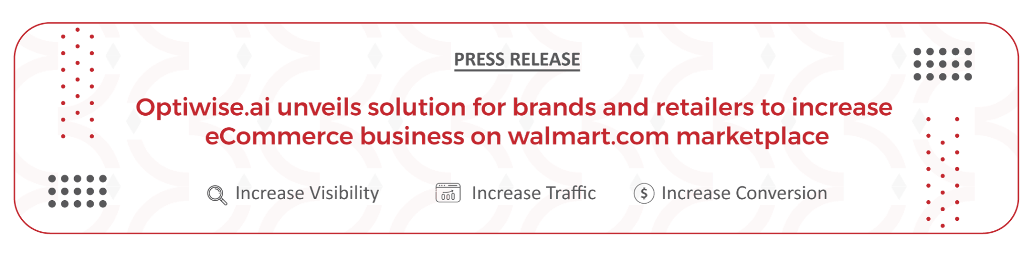

Optiwise.ai - Combining the power of machine learning and human intelligence to automate your marketplace optimization and increase eCommerce sales

Newark, CA - September 19, 2022: Optiwise.ai, Inc ("Optiwise"), a leading marketplace optimization company, announces the launch of [Optiwise.ai](https://www.optiwise.ai/), a comprehensive solution to help brands and retailers in scaling their ecommerce business on the Walmart.com marketplace. Optiwise.ai is a cloud-based software platform that for the very first time in the history of eCommerce, combines the power of machine learning and artificial intelligence with the experience of a seasoned team of data scientists with decades of ecommerce experience to provide actionable insights and optimize performance across Walmart, Amazon, and other marketplaces.

The US e-commerce is expected to surpass [$1 trillion](https://www.insiderintelligence.com/newsroom/index.php/us-ecommerce-will-cross-1-trillion-in-2022/)* for the first time in 2022, paving the way for these sellers to exponentially grow their businesses on marketplaces such as Amazon, Walmart, eBay and others. Because of the level of success that these sellers have seen on Amazon, Amazon has become the preferred choice for most sellers, followed by Walmart. However, these sellers have been unable to replicate their success on the Walmart marketplace for various reasons, including onboarding challenges, a lack of a marketplace optimization strategy, lack of paid ad expertise, rich media, and so on.

To address these challenges and assist sellers in growing their business on Walmart, Optiwise.ai, Inc has introduced Optiwise.ai, a comprehensive end-to-end solution AI-based SaaS platform. This machine learning platform is the result of over ten years of experience, a partnership with Walmart, and extensive knowledge of scaling eCommerce businesses. The platform provides a variety of solutions to assist sellers in managing all aspects of their business.

Using this powerful, easy-to-use self-service platform, sellers have one-click access to their product pages' content health score, issues with their existing content and recommendations on how to optimize these pages for increased traffic, conversions and sales. By leveraging Optiwise.ai, retailers and brands can create, edit and publish enhanced content, track content health score and revenue and receive customized weekly reports.

**Optiwise.ai solution includes:**

• One-click Optimization • Enhanced Content • Rich Media Support

• Paid advertising expertise • Search Rank Tracking • Account Setup Support

• Cross-marketplace Recommendation • Success Metrics Reports • Auto Publisher

• Cross marketplace Performance • Alerts & Notifications • Dedicated Support

Optiwise.ai is now available for general release and with hundreds of Walmart sellers already on this platform, Optiwise.ai has been able to provide exceptional value to more than 90% of these sellers who were struggling to increase their sales on Walmart. These sellers have experienced a significant growth in their overall business metrics such as 3.2X increase in traffic, 46% increase in conversion and 2X increase in sales.

Optiwise.ai will be launched and showcased at the Sell + Scale Helium 10 Summit, booth #438, on September 20-22, 2022, at the Virgin Hotel in Las Vegas. If you are a Walmart seller, stop by the booth and speak with our Walmart experts for free sign-up and product demo. Deepak Goyal, Co-founder and CEO of Optiwise.ai Inc, will be at the booth to address any queries.

Optiwise.ai is offering 20% off and other great offers if you [sign up for Optiwise.ai](https://app.optiwise.ai/login) in the next few days! You can also request a demo: <https://www.optiwise.ai/contact-us-walmart>

**Recent Client Experiences**

*“Optiwise.ai has provided excellent services to us. The listings quality was very high (we've reviewed one by one) and it was done quickly and with a fast response time. Highly recommend Optiwise.ai for the listing optimization services”*

*“Optiwise.ai has consistently given us outstanding performance & customer service from day one! We are very happy and excited to work with them”*

*“We have just started with Optiwise.ai but so far they have been great. If I compare them to the team that we have to support our other eCommerce channel, its night and day different”*

**About Optiwise.ai, Inc**

[Optiwise.ai](https://www.optiwise.ai/) (eZdia Inc)is a leading global digital marketing organization that specializes in developing conversion focused eContent for marketplaces, brands and retailers since 2012.

With over a decade of experience on Walmart marketplace, combined with the power of our platform and the intelligence of our expert team of e-commerce specialists, data scientists, we have created a one-of-a-kind Saas platform that helps Walmart sellers significantly increase their revenue.

Optiwise.ai, Inc has helped over 15,000 brands to attract, engage and convert business across 12 languages and markets globally and 1M+ pages optimized, over 470 categories.

Optiwise.ai Inc is headquartered in California and has a presence in India and other countries globally.

**Optiwise.ai Media Contact**

Email: marketing@optiwise.ai